Introduction to IoT Core Services

|  |  |
| --- | --- |
| Title | Introduction to IoT Core Services |
| By: | Meenakshi Murugappan |
| Student Id: | L00156569 |

# Summary

This Build book describes the practical work carried out on the AWS IoT core services and test the same using the MQTT client provided in the AWS Console.

It describes the following tasks:

1. Accessing the IoT Core Services in AWS Console.
2. Understand the Publish and Subscribe mechanism using MQTT Client in AWS Console.

Contents

Summary 1

Resources and Prerequisites 3

Introduction 3

Steps 3

Summary 4

References 5

# Resources and Prerequisites

1. Valid AWS credentials to sign into the AWS console to access the services

# Introduction

This build book provides the instruction to AWS IoT Core services and test the functionality using MQTT test client by publishing and subscribing to a message.

# Steps

1. Valid credential to Login to the AWS console. If the credentials are not available, It can be created using the Link [[1]](https://aws.amazon.com/), by clicking the “Create and AWS Account” button as shown in below Image.

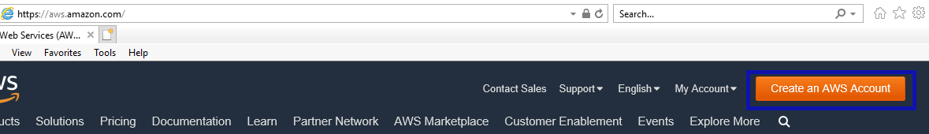

Note: This may require valid credit/debit card details. The AWS account is free for 12 months with limited function, please refer this link [[2]](https://aws.amazon.com/free/) for more details.

1. Once Login to the AWS Console, navigate to the “AWS IoT Core” services as show below

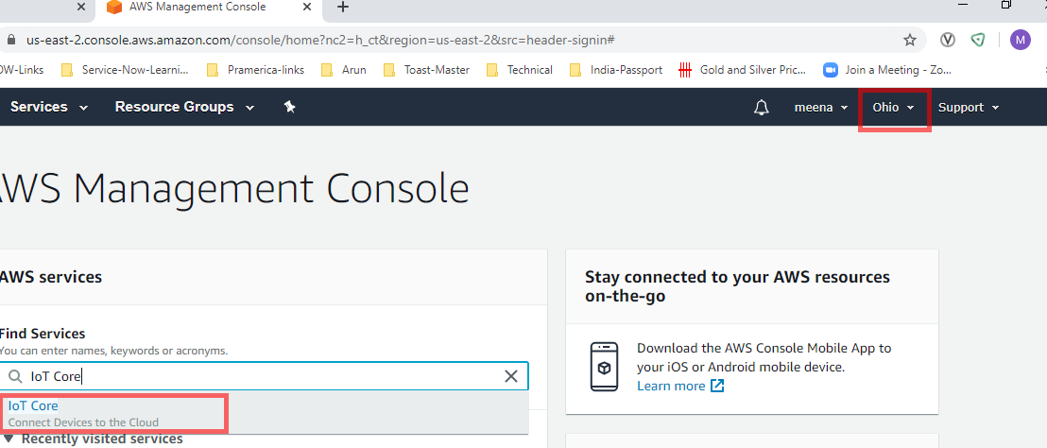

Note : Use the default region US-east-2, this is the first region where all new services are introduced.

1. Once Navigated to the IoT Core, click on the Test on the left navigation to Publish and subscribe a topic.

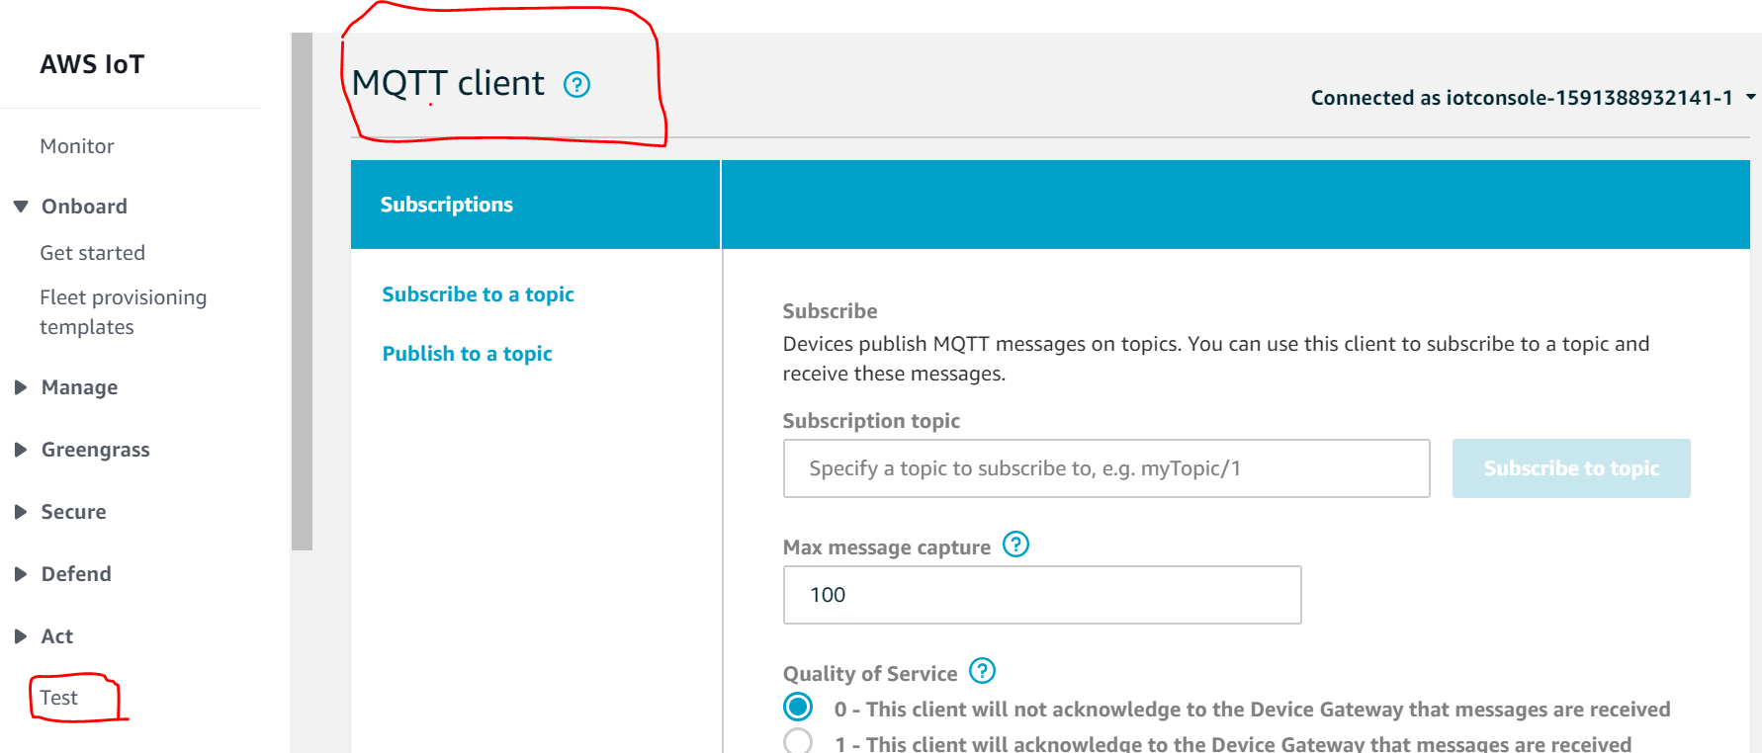

1. Click on Subscribe to a topic on the left nav and Type “myFirstTopic” and click the “Subscribe to topic” button as shown below.
2. Click on Publish to Topic on the left and try to publish messages as shown below to test the functionality.

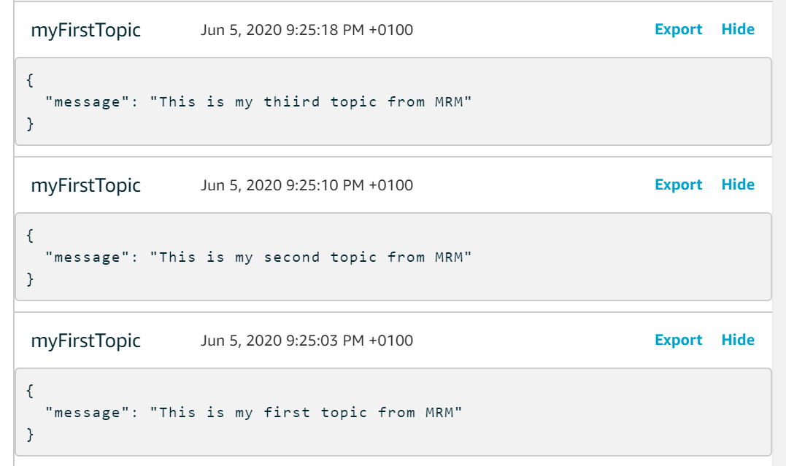

# Summary

The purpose of the above exercise is to understand the basic mechanism of MQTT publish and subscribe to the topic. By completing the above exercise will help to understand how to publish the message from the devices in the Industrial IoT world. Later this concept can be used to publish the message virtual MQTT client or simulated MQTT client or real embedded devices.

# References

[1] Amazon web services, https://aws.amazon.com/, accessed 05-May-2019

[2] AWS Free Tier, <https://aws.amazon.com/free/>, accessed 05-May-2019.